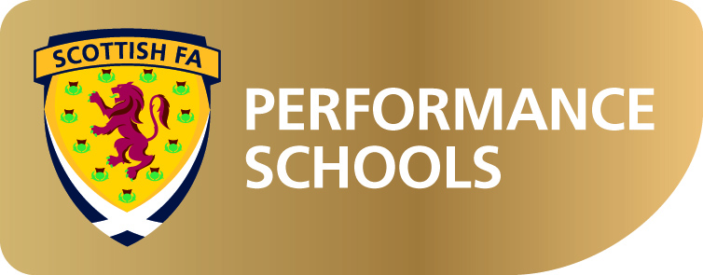

To: Parents/Guardians of
All P7 Children

Dear

Scottish FA Performance School – Holyrood Secondary

The Scottish FA is delighted to announce the application process for the Performance School 2014 is now open.

The programme is open to boys and girls in the current P7 cohort of our primary schools who have shown talent in football and would benefit from an individualised programme. It is aimed at players who are the most talented and requires a full commitment on the family and young player’s part. The programme is based at Holyrood Secondary and will require all pupils to complete a placing request, if selected for the programme. All parents/carers are responsible for transporting the successful candidates to Holyrood Secondary. Glasgow council will not be funding travel costs, however, the Scottish FA may make a contribution to travel costs in individual circumstances. The pupils' timetables will be altered to allow them to follow the programme during curriculum time.
The aim is to bring together the best young footballers from the area into four year training and support programme designed by the Scottish Football Association, Performance Youth coaches (full time employees of the Scottish FA) with additional experts in fitness training and conditioning.
The Performance Manager and the Head Teacher at Holyrood Secondary will have overall responsibility for the direction and organisation of the Performance School and will ensure pupils achieve the right balance between sport and academic life.

If you require more information or would like to be considered for a place at the Performance School then please click on the link below:

www.scottishfa.co.uk/performance

This is a significant commitment from all parties, including the children and families who will be selected so please note this programme is designed for the best young football players.

Yours in football

Brian Mclaughlin
Scottish FA Elite Performance Coach

