
Duncanrig Secondary School
Newsletter – May 2012

Dear Parents and Carers

SQA exams are now upon us and I ask for your support in encouraging and supporting your children in their preparations over the coming weeks. Pupils should be following study plans to take full advantage of the Study Leave period. Please ensure that they are not wasting this time on long lies, computer gaming, social networking and “retail therapy” but are studying in an organised manner.
Staff are heavily involved in developing Curriculum for Excellence courses in S1-S3 and planning the development of National Certificate courses for S4- S6 pupils over the next few years to replace the existing qualifications courses. As we settle on a curriculum structure and pattern for the “Senior Phase” (S4-6) you will be both informed and consulted with regards to curricular pathways for our pupils as we prepare them for positive, post-school destinations.
Pupils have been heavily involved in a huge range of events outwith the classroom both as curricular and extra-curricular activities. The success they have enjoyed is recorded in detail in this newsletter.
George Wynne, Headteacher

Combating Sectarianism:
HMIe Good Practice Visit to Duncanrig

Her Majesty’s Inspectors of Education were invited to visit Duncanrig by ‘Nil by Mouth’, the anti-sectarian charity, to see the quality of work being done in our school.
The inspector spent a day with us looking at our anti-sectarian and tolerance programmes and the links with our partner primaries and other schools in the town. She spoke to staff and pupils and sat in on lessons to see the practice for herself.
S2 have been working on an anti-sectarianism unit, to try to create solutions for sectarianism. Groups of S2 pupils prepared lessons to be delivered in local primary schools and have achieved great success in this.
Senior pupils have created a ‘Pupil Charter’ which will be used to promote positive attitudes and behaviour in school. This will be presented to pupils at special assemblies over the next few weeks, and will hopefully see Duncanrig becoming one of the first schools in Scotland to achieve ‘Nil by Mouth Champion for Change’ accreditation. Our colleagues in St Andrews & St Brides have also agreed to a charity football match before the end of the summer term to help us raise money for ‘Nil by Mouth’.
We are extremely proud of all the work done by Duncanrig pupils to address this issue.



Plea to Parents from Staff in our School Office

Could you please ensure that you notify us when you change email addresses and mobile telephone numbers. Some of our communications to parents are “bouncing back” because numbers and/or addresses are no longer valid.

Three National Sports Titles for Duncanrig Girls!

Scottish Schools U14 Football Champions

Out of 60 teams from all over Scotland, our girls won the Scottish Schools Football Association Girls U14’s Sevens Tournament. The tournament, sponsored by Lloyds TSB, reached its culmination at Toryglen Indoor Arena in Glasgow where 6 finalists battled it out for the top spot.
Duncanrig girls ran out worthy winners in a tense final against the pre-match favourites, St Ninian’s High School, Giffnock. After dominating the early play with Ashley McKeown hitting the post and a good strike from Cara McGurn, the Duncanrig girls found themselves a goal down. This did not deter them as they responded with strength, determination and 2 goals from Karen Baillie and Lucy Pollock respectively. Coach Ainsley Douglas and Assistant Coach Jade Robertson got special a mention from Ronnie Hamilton of the SSFA for their professionalism and motivational leadership.
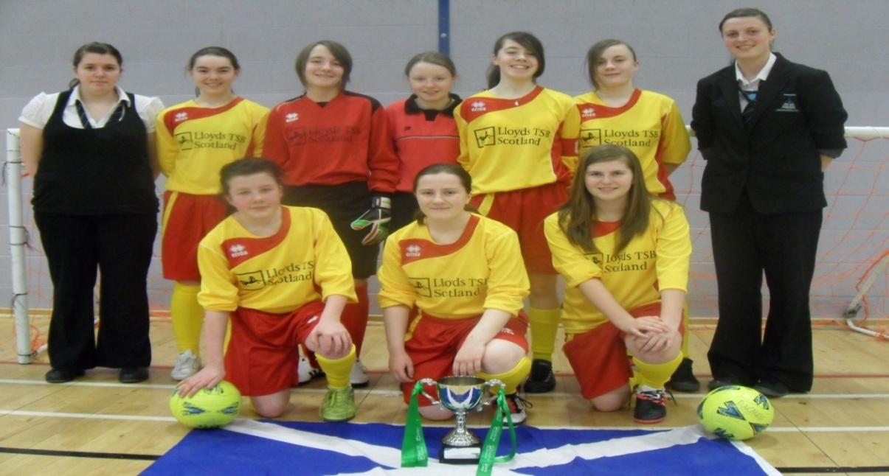
Ainsley said, ‘The competition was of a very high standard and the girls had to play extremely well to see off their opponents. I was delighted by how well they gelled as a team.’

Back row - left to right) Jade Robertson, Stephanie Reilly, Emma Clark, Katie Craigie,
Cara McGurn, Ashley McKeown, Ainsley Douglas,
Front row - Hannah Johnston, Caitlin O’Neill, Karen Baillie.
(Also in squad but not in picture) Jacqueline Carrigan, Tasmin Shaw, Lucy Pollock

The championship win contributed to the nomination of Duncanrig as the SFA Football School of the Month for April.

Parent Council Provides Clothes Bank

We are the proud owners of a new clothes bank! The bank is the brainchild of our Parent Council and has been installed at the front of the school on the path down to Duncanrig Sports Centre. The Parent Council have taken forward this initiative to raise funds for school activities. It is hoped to raise between £2,000 and £3,000 pounds per year to pay for extra-curricular equipment and transport costs for pupils representing our school in competitions and to help fund the costs of going on educational visits.
Please support this venture by depositing old clothes in the bank whenever you can. Your support will be greatly appreciated and help us support the huge range of activities that our pupils are able to take advantage of. I had the honour of making the first deposit having “pruned” the wardrobes of my 4 children. Please dare to venture into the wardrobes and drawers of your children and fill some bags – it means less washing and ironing!

Scottish Schools Netball Senior Champions

Congratulations to our Senior Netball Team who won the Scottish Cup Final, beating Holy Cross HS 48-40 in a very exciting match held at the Revenscraig National Sports complex in Motherwell.
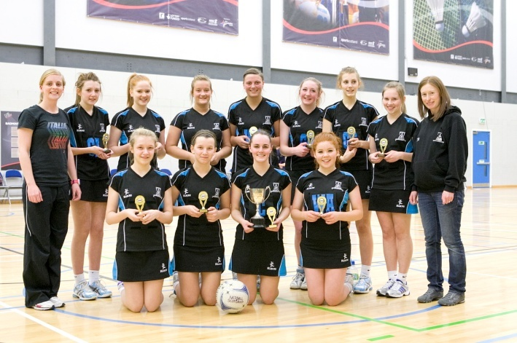
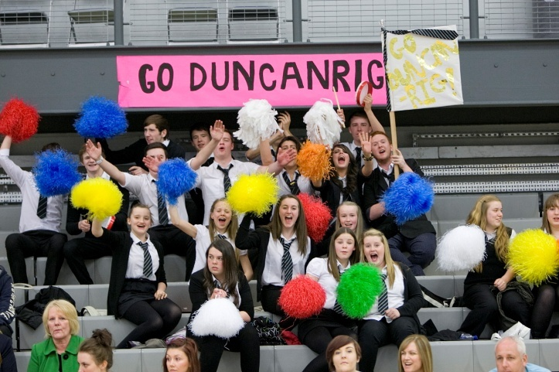

The Team: Emma Hardie, Stacey Mitchell, Amy Fyfe, Ainsley Douglas, Rebecca Tavendale, Joanne Malloy, Katie Gallagher, Jessica Smith, Stephanie Hagerty, Lauren McSkimming and Jacqueline Murphy worked so well together and thoroughly deserved their victory.
The success continues for some of the girls as Netball Scotland recently announced their U17 and U21 National Squads for the European Championships. Katie Gallagher and Jacqueline Murphy were selected for the U17 Championships in Glasgow. Emma Hardie was selected for the U21 Championships in Belfast. Well Done to the girls!

Scottish S1/S2 Handball Champions

Well done to the Duncanrig junior handball teams who represented the school at the Scottish Championships. The girls’ team played excellent handball to retain their title with top scorer Monica Gallacher selected as player of the tournament.
The boys’ team won the morning section and played a thrilling final against Calderglen in a closely fought encounter. Calderglen edged the game 7-6 with Duncanrig unlucky to see a last minute penalty saved.

Duncanrig Has A European Champion!

S5 pupil, David Gray was selected to represent Scotland at the ‘Tae Kwon do’ European Championships in Slovenia in April. David competed as an individual in Patterns and Sparring and in both these categories he reached the last 16. There were 48 boys in David's division so he did well getting to the third round.
He is also the Captain of the Junior Male Team. This comprises 5 boys who do synchronised patterns, spar against another 5 boys and team power (breaking of boards with hands and feet). David trains for 7 hours every Saturday in Aberdeen to ensure the boys work as one. The Scotland junior male team won bronze for patterns being put out by Germany who went on to win. They also won bronze for sparring beating Norway and Spain before being put out by the eventual winners Ukraine. However in Team Power, they took Gold making them the European Champions. This event is normally won by one of the Eastern European countries so well done to the boys.
David’s success continued when he returned homw as he won the ‘Junior Male Sports Personality of the Year award.

Duncanrig’s Olympic Adventure
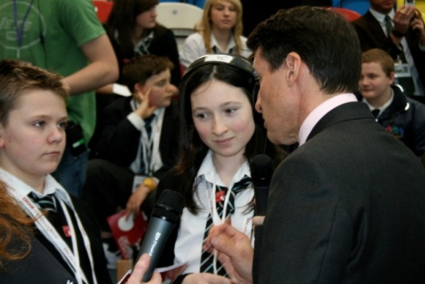
Duncanrig, pupils were given the opportunity of a lifetime when they were selected to visit the Olympic Park in London to report for the BBC. S2 pupils, Greg Ross and Alix Aitken were chosen to be the only representatives from Scotland to take a tour of the Olympic Park and interview 2 times Olympic Gold medallist and Chair of the Olympic Committee for the London 2012 Games, Lord Sebastian Coe at a press conference for BBC News School Report on 15th March.
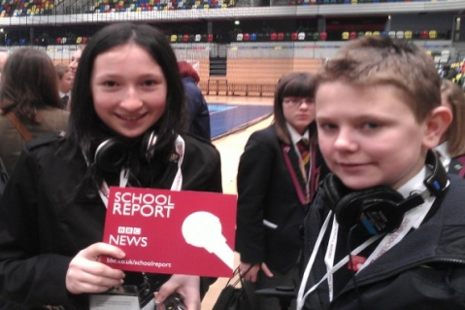
Teacher and Radio Duncanrig co-ordinator, Mr Gerrard explained “I was absolutely delighted when I got the call from the BBC asking if we would send 2 pupils from the radio station to report for the News School Report Day from the Olympic Park in London. The BBC has been very impressed with everything the radio station has achieved so far and immediately thought of asking our radio presenters to be involved. ”

Before heading for London, Greg and Alix appeared on “The Fred MacAuley Show” on BBC Radio Scotland to promote the event.
On BBC News School Report Day, the pupils were given a bus tour of the Olympic Park where they got to see all 9 venues up close, including the Olympic Stadium. Alix explained “It was very foggy in the morning which spoilt the view a bit, but we still did get to see all the venues up close and they all looked amazing”. Greg and Alix did a great job for the BBC on the day and we were 1 of the 2 schools selected to interview Lord Coe personally after the group press conference. They also featured heavily on the BBC News throughout the day and on BBC News 24 channel.

Parents as Partners: Uniform
Please continue to support our efforts to uphold standards in uniform. Recently we have seen a slight, but noticeable, increase in the wearing of clothes that do not comply with our uniform code.

Some pupils have taken to wearing black jeans instead of formal trousers. Girls are particularly guilty of wearing trousers of brushed denim or similar materials and arguing that they are not jeans. They may think that they are not jeans but they are not formal school trousers and are unacceptable.
As the weather has improved, a number of girls have turned up to school wearing very short skirts. These are inappropriate for school and must not be worn. Similarly, a number of pupils have “forgotten” to put on a tie in the morning and they are invariably “in the washing”, “at my Grannies” or have been eaten by hungry pets.
Another recent trend is the abandoning of black footwear for white or even multi-coloured shoes and trainers. Black shoes are required of pupils.

Our uniform code states that plain black tops must be worn. Whilst almost all pupils come to school in appropriate tops a number of pupils have taken to wearing white, grey or coloured tops.

Please support us in our efforts to maintain standards and check that your child is coming to school suitably dressed. I find it hard to believe the claims of pupils that so many mums are to blame for the lack of uniform because they are constantly behind with the washing and/or ironing.

I realise that this can be a stressful topic at home but urge you to support us.

Glasgow Music Festival Success

Our Concert Band were awarded second place in the Concert Band B class at Glasgow Music Festival in March. They had the opportunity to perform in the Glasgow Royal Concert Hall and faced some tough competition from 7 other Scottish schools. Our Ceilidh Band and Choir also participated in the festival and received excellent comments from the adjudicators.

Music and Drama Festival

Our Music and Drama festival will take place in Westwood Church on Monday 11th June 1.00 -3.30 pm (Young Orchestral Musician of the Year and Young Composer of the Year) and Tuesday 12th June 1.00 -3.30 pm (Young Performer of the Year and Young Contemporary Musician of the Year). Parents and friends are very welcome to come along and support our pupils and there will be a small charge of £2 entry on the door. The winners of each class will be invited to perform at our Summer Concert on June 14th.

Summer Concert

This year’s Summer Concert will be held in the Street Area on Thursday 14th June at 7 pm. The concert will include items from our Secondary and Partner Primary music groups in addition to performances from our Music and Drama festival winners. Tickets, priced £4 adults and £2 concession, will be available from the Music and Drama base at the end of May.

National Youth Jazz Orchestra

Congratulations to Callum Neil, S2, who recently auditioned for the National Youth Jazz Orchestra of Scotland Access Big Band and has been accepted to attend the course on the 16-18th of March at Broughton High School. The weekend of rehearsals will culminate in a gig at the Jazz Bar on the Sunday afternoon. This is a fantastic achievement.

Music Exam Success

Congratulations to Orla Jenkins, 2C1 who recently achieved a merit in her Grade 4 flute exam and to Ciaran Mullins, 2A2 who achieved a Distinction for his Grade 4 piano exam.

Kits for Kids

Tokens are being published in The Daily Record and The Sunday Mail every day until Saturday 19th May. Please collect these tokens to support us as we buy kit for various school teams. All tokens must be sent to our School Office or Mr Miller, Technical Technician by 31st May.

Poppy Scotland

We were delighted to receive a certificate from Poppy Scotland for the short film created by our pupils to support their work. We received a “Highly Commended” award in recognition of the quality of the film and the efforts and talents of the pupils who had created it. Our film will be preserved by The National Library of Scotland for future generations to enjoy.

Public Speaking and Debating Club Success

It’s been a busy few months for club members who have been representing Duncanrig in a variety of competitions.

In March, Megan Sutherland and Greg Hughes of S2 progressed to the second round of the ESU Juniors Debating competition and were narrowly beaten to a place in the quarter finals. Lucy Coyle and Sarah Johnston of S1 also competed in the first round and although they did not get through, they did exceptionally well in their first debate.
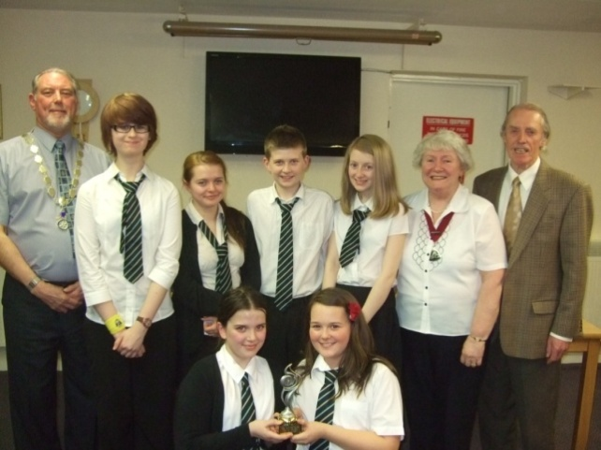
EK Rotary Club organised an ‘all EK’ Public Speaking competition. Duncanrig entered 2 teams: Amy Cook, Sarah Johnston and Lucy Coyle; and Lindsay Denholm, Holly Shields and Greg Hughes. The teams were judged by members of the East Kilbride Speakers’ Club and we are delighted to report that we brought home the trophy. The winning team of Lindsay, Holly and Greg was then invited to lunch with the Rotary Club at the end of last term. They had to ‘speak for their supper’ though.

Pictured with them, and members of the Rotary Club and the EK Speakers Club, are Amy Cook, Lucy Coyle and Sarah Johnston, who also took part.

As we look ahead to the summer term, we are in preparation for the John Walker Public Speaking competition, in which we are fielding a team of S1 pupils: Robert Griffiths, Callum Blair, Lucy Coyle, Sarah Johnston and Eilidh Russell. They have put together a presentation on the topic of Sectarianism and will work together to present this at the end of May.

In June, we are planning to host a debate in Duncanrig, featuring staff, pupils and other guest speakers. Our topic will be very controversial and we expect sparks to fly!
A Letter from a Neighbour

Dear Mr Wynne

I would like to express my gratitude to your pupils, who returned my car keys. Unfortunately I did not gather their names when they helped me. However, I feel that it is extremely important to write to your school to express my gratitude to the pupils and to encourage their good behaviour.

Around 3.15 I was running in Manitoba Crescent to the bus stop and I dropped my car key. Five minutes later I realised that I had dropped them and immediately returned to the street trying to hunt them down. Luckily your pupils – a group of 4 or 5 had picked up the key and were waiting beside the car for my return.

Again, I would like to express sincerely my gratitude to your pupils. I am gutted that I forgot to take down their names.

Please pass on my message to them.

Visit our website and add yourself to our mailing list if you wish to receive updates and notifications by email.

www.duncanrig.s-lanark.sch.uk
Diamond Jubiliee Celebrations

To celebrate the Queen’s Diamond Jubilee, Radio Duncanrig will be presenting a radio show the pupils will talk about the life and times of Queen Elizabeth 2nd as well as featuring music from the artists that will be playing at her concert.

We are also planning to display a private collection of royal photographs, taken over the last 35 year by one of our members of staff. The photographs are unique and will be displayed in our School Library.

Staff News
We are delighted to welcome Miss V Rice who joins us from Carluke High School as our new Principal Teacher of Guidance.
Miss K Barton (Modern Studies) has left us to join Hamilton Grammar School on a permanent contract. We wish her well in her new post.

Duke of Edinburgh’sAward

In S3, 24 pupils are working on their Duke of Edinburgh Bronze Awards. The pupils have been working hard every second Tuesday after school in order to learn camp craft skills such as putting up tents, packing a rucksack, map-reading, using a compass, and working in a team. They have also been getting started on the physical, skills and service parts of the Award.
The pupils are now looking forward to the Practice and Qualifying Expeditions. The Practice Expedition will take place on Monday 14th and Tuesday 15th May and will involve walking and camping at Guay in Perthshire. The Qualifying Expedition will be on Monday 11th and Tuesday 12th June in the Pentland Hills, camping at Bonaly campsite.
Duncanrig Rugby Success

Our S3/4s won the Lanarkshire Bowl at the finals evening held at Hamilton RFC beating St. Maurices convincingly.

Gavin Russell, Ross Hynd, Josh MacDonald, Euan McKirdy, Ross Campbell, Craig Muldoon, Ross Arthur,
Aaron Harrington, Mark Donachie, Andrew Jamieson (cpt), Callum Brown, Roddy Beaton, Tom Cree,
Ewan Ferguson.

We also came runner-up in our very own second annual U18 7-a-side tournament, losing to an outstanding Carrick Academy team in the final on our main pitch. Six other teams, a total of 7 schools, also competed on both our pitches ably aided by some of our younger players as well as a special “Thank You” to Kyle McGrath and Dean Maxwell who helped make the festival run smoothly. The medals were presented by Glasgow Warriors’ back row players Rob Harley.

Deck the Walls

We have been made an offer to cover some of the whiteness of the walls in the Street area through the application of quotations and photographs. The idea stems from another school where quotes from famous and not-so-famous people have been applied to the walls.

The suggestion is that we follow this example and our building owners have offered the use of a high level pneumatic platform to allow this to go ahead during breaks in the school year. The quotes can be philosophical, whimsical, profound, inspiring or just plain funny and can be drawn from literature, sport, politics, music, drama or any other area of high or popular culture.

Photographs must be of either our school or the wider East Kilbride area and must be of good enough quality to be enlarged to a size big enough to have a presence in the street area.

If you would like a quote or photograph considered for selection please send it/them to office@duncanrig.s-lanark.sch.uk and I will create a bank that we can put forward for consideration by staff and pupils.

Physics S1 Rally Championship

The Physics department recently ran their annual rally tournament for S1 pupils that involves negotiating a remote control car around a course laid out in the Physics lab. Pupils get the chance to prove their ‘Stig-like’ qualities and show up the older generations with how good their hand-eye co-ordination is.

Mr Wynne awarded:

GOLD to Connor McNeil of 1B3 who completed the course in 13.271s,
SILVER to Kyle McGettigan of 1B3 who had a time of 14.021s
BRONZE to Harry Becker of 1A2 who held first position until the very last moment with a time of 14.310s.

Thank you to the staff and pupils who have supported the Physics S1 Rally. The Luwero Fund and Marie Curie Hospice have benefited from the proceeds this rally generates. If you are a P7 reading this we look forward to seeing you next year.

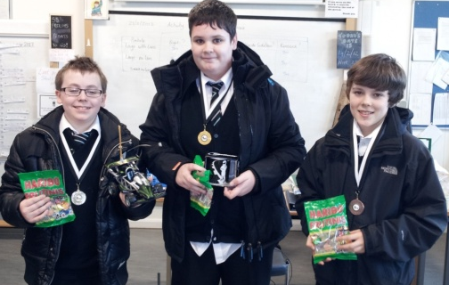

Dear Friends at Duncanrig Secondary

We continue to be grateful for the support offered from our friend in East Kilbride and want to provide you with an update of recent events.

The 4th primary school classroom block is now nearing completion following the storm damage caused whilst under construction a few weeks ago. We are grateful to donors who have provided funds for the re-building work.
Rain during the past 2-3 weeks was welcome following a long period of drought. Recent rains have also meant that the well is operational again and crops can be planted.
470 children now attend the primary school and 70 attend the secondary school. Schools at present are on 3 weeks holiday.
74 boxes of donated goods which are being shipped to Luwero in May.
Recent visits of a number of friends from the UK to Luwero between January and April.
The offer of school furniture from a Scottish school being rebuilt for shipment to Luwero.
We are experiencing problems resulting from inflation and drought including food and fuel shortages.

Your prayerful interest and concerns are graciously appreciated.

Gabriel

