 West Dunbartonshire Council
Department of Educational Services

AITKENBAR PRIMARY SCHOOL

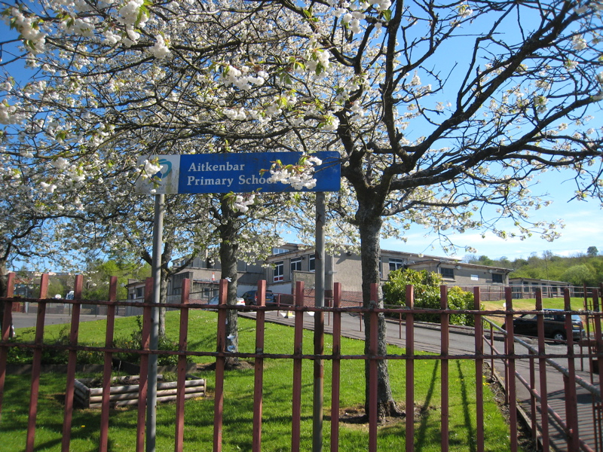

Standards & Quality Report
June 2013

Headteacher Christine Hutchison Date June 2013

QIO Ronnie Thumath Date June 2013

GOOD PRACTICE
OUTDOOR LEARNING has always been given high priority in Aitkenbar
Primary School. During session 2012 –2013, many opportunities for
Outdoor Learning were presented. Aitkenbar has extensive green
space around the school and our pupils can often be seen exploring the
school grounds with magnifying pots and clipboards.

We are fortunate to be within walking distance of Overtoun Estate
and have been able to take advantage of the wonderful activities and events provided by the Woodland Trust. Over the next three years the Woodland Trust Scotland will plant 200,000 native trees at Lang Craigs in the Overtoun Estate with the help of local children. This will create a large new wood that will benefit people and wildlife.
Outdoor Learning has enabled us to work with parents and partners as well as providing creative, challenging, enjoyable and adventurous experiences for our children. This session our children have worked with:
- Bellsmyre Development Trust – developing the Bellsmyre Community Gardens
- Woodland Trust - tree planting at Lang Craigs, learning about local wildlife, sustainable forests, the importance of trees to the environment
- The Countryside Ranger – various trips to Overtoun Estate to work with the Ranger - Mini beasts topic and Beavers topic
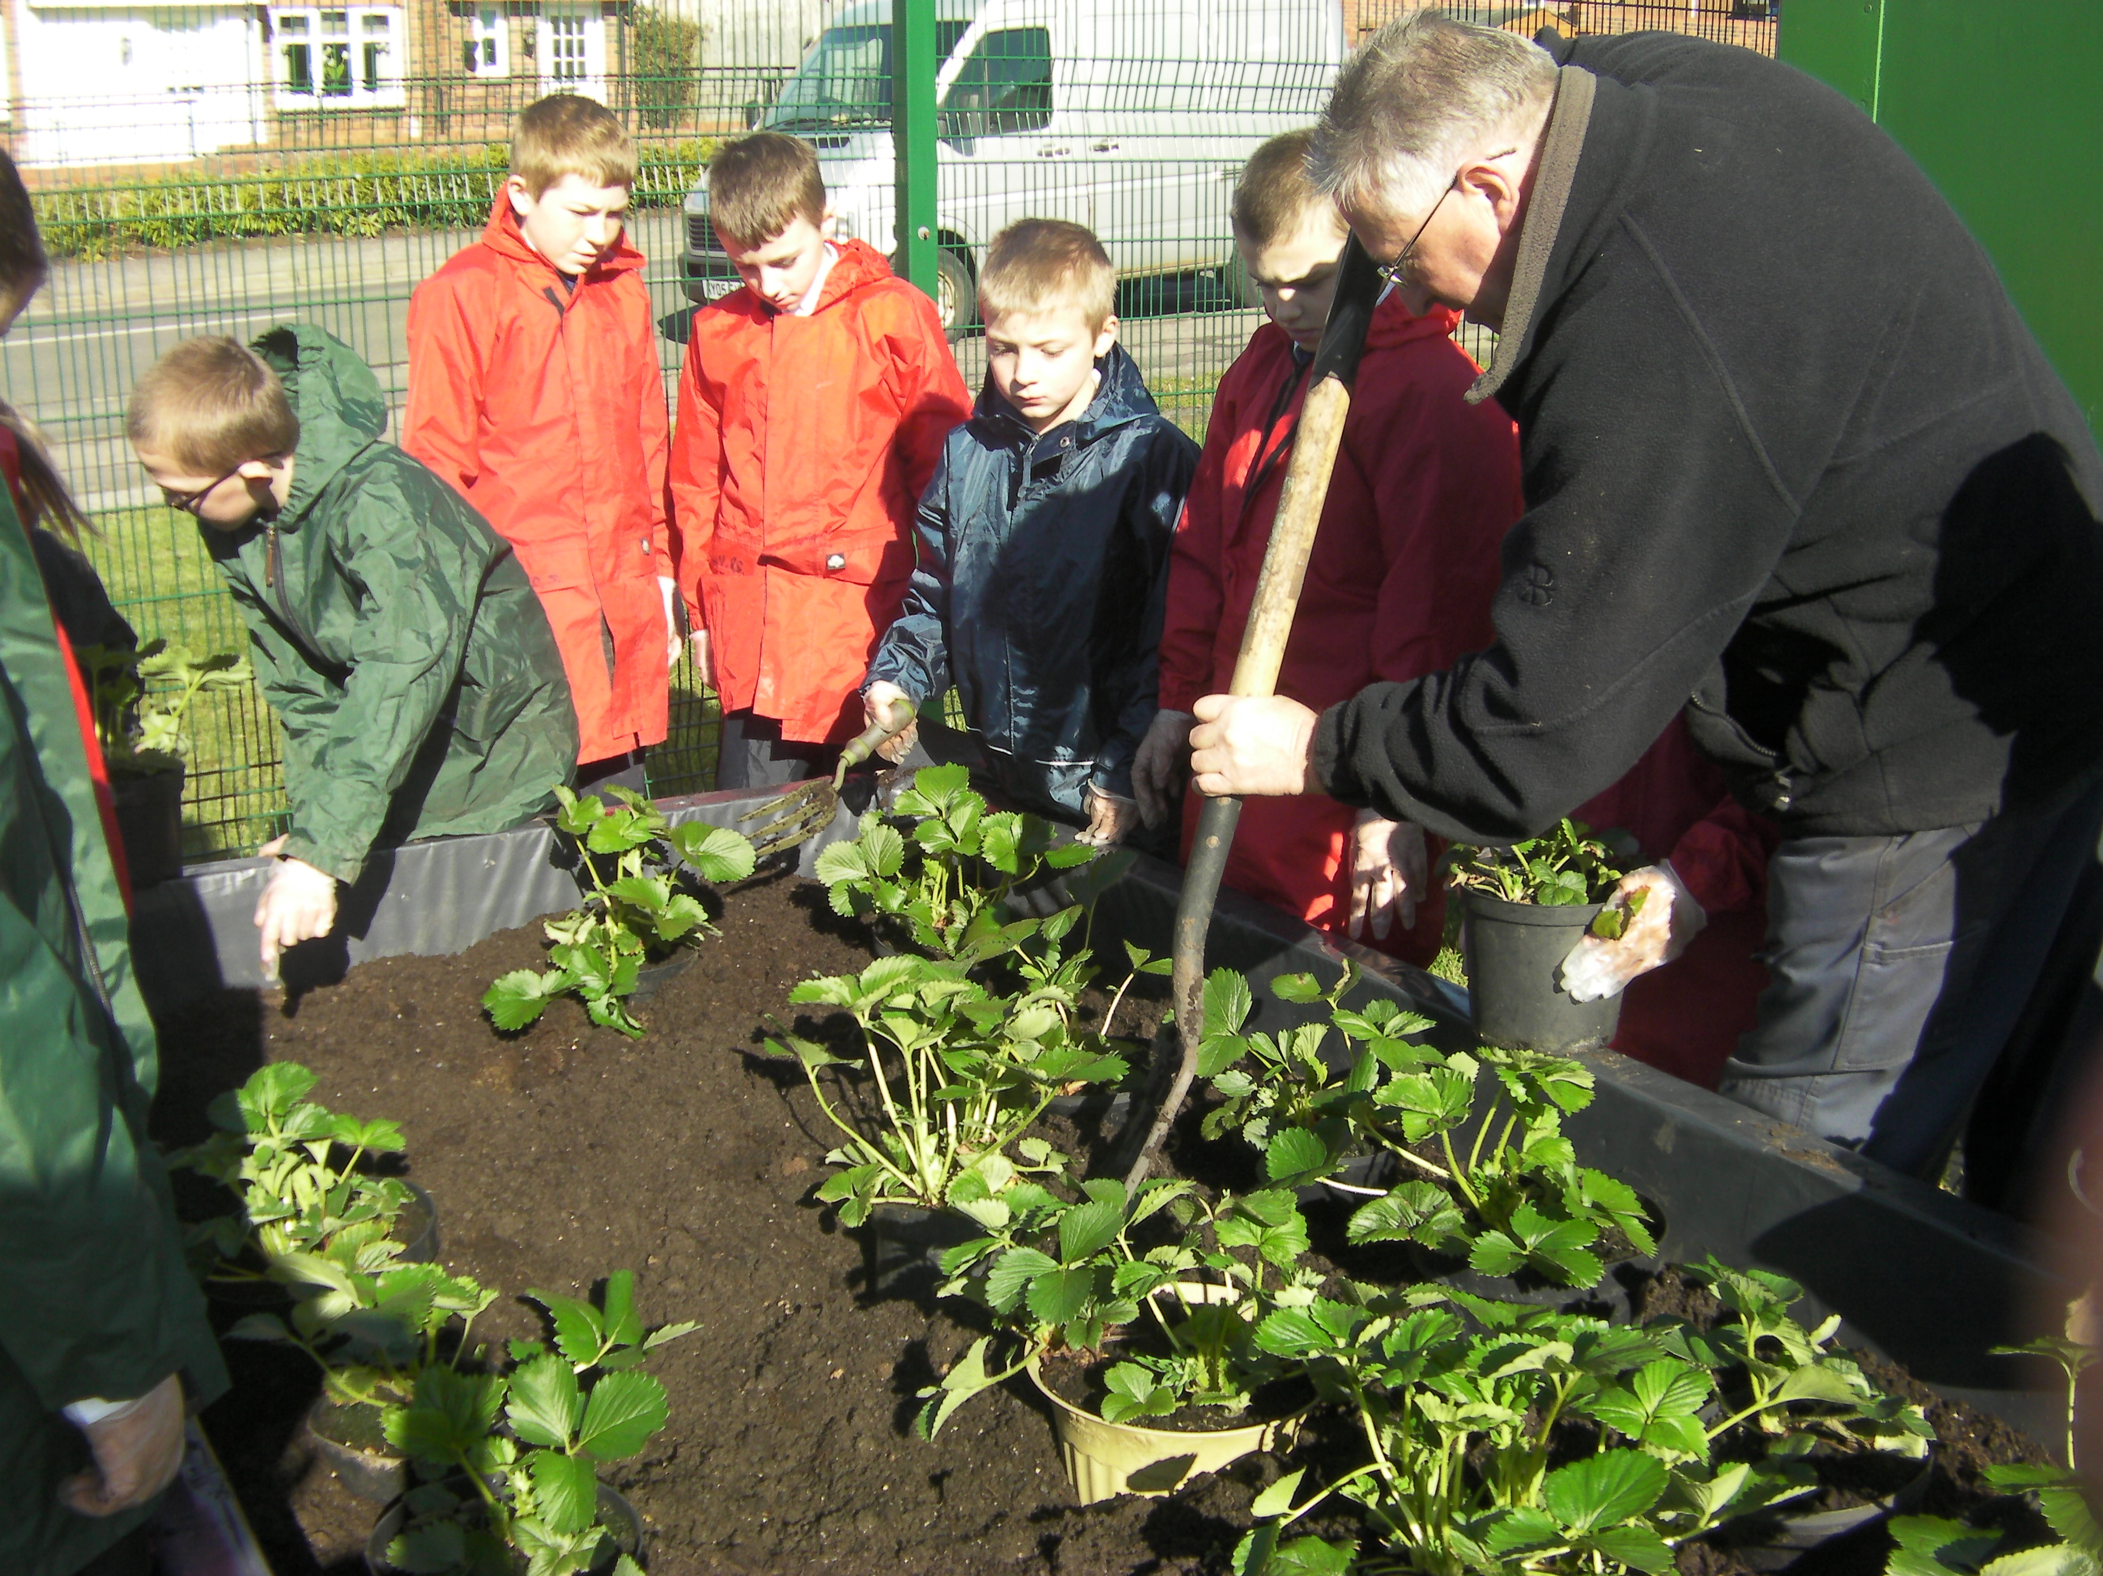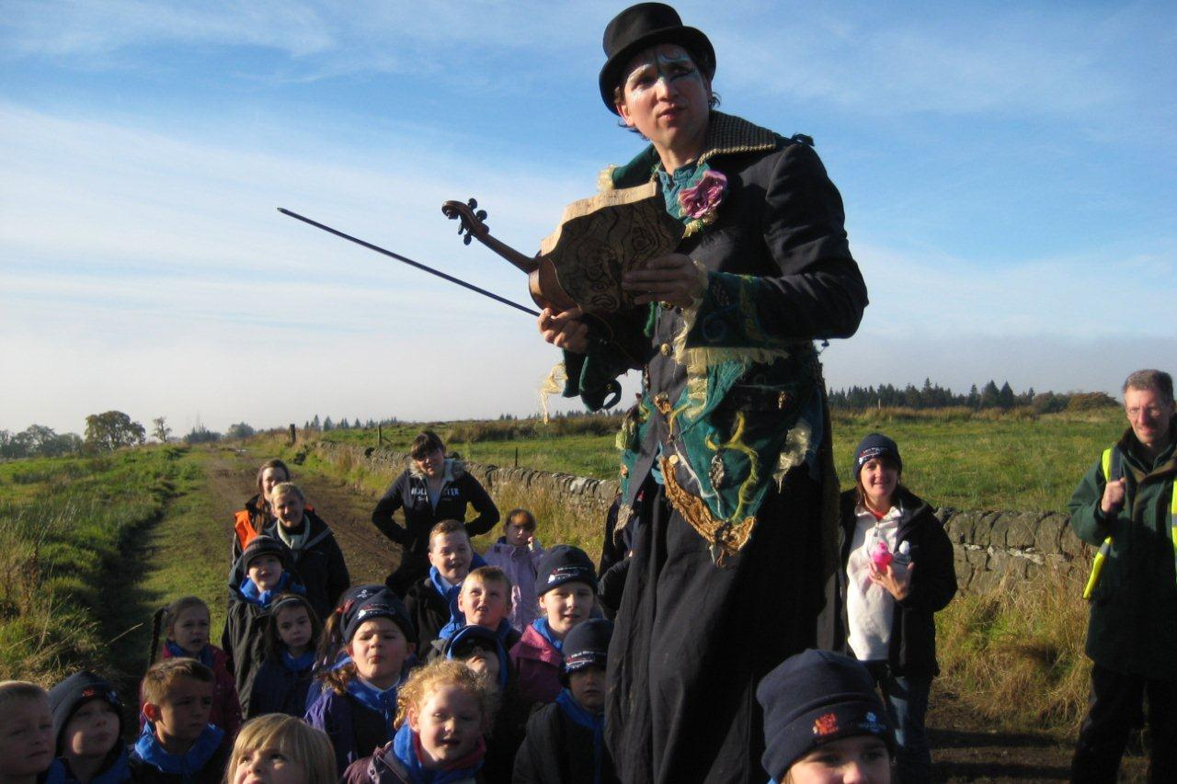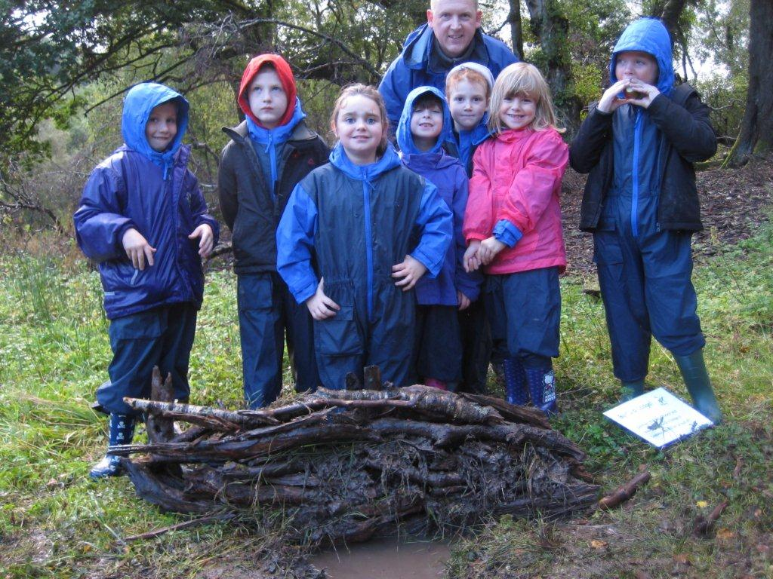
Working in the Bellsmyre Tree Planting with the Building Beavers’ Lodge
Community Garden Woodland Trust at Overtoun Estate
Many of our interdisciplinary topics have outdoor learning built in at the planning stage. Further opportunities are taken as they arise. Links to other curricular areas such as literacy, numeracy and health and wellbeing are developed and enriched through outdoor learning. The children report that ootdoor experiences make their learning ‘real’. Staff report that children are more engaged and motivated in their learning; their skills of enquiry, critical thinking and reflection are enhanced; challenge, enjoyment, relevance and depth of learning is clearly evident when children learn outdoors.

Whole school initiatives also include opportunities for Outdoor Learning. The Eco School Council and the Gardening Group meet regularly to lead and develop work in the school grounds where they develop skills of teamwork, enterprise and sustainable development.

Outdoor Learning opportunities deliver Curriculum for Excellence
in an exciting and relevant manner – the impact is clear to see in
children who are fully engaged and engrossed in the experiences provided.

Exploring the school grounds
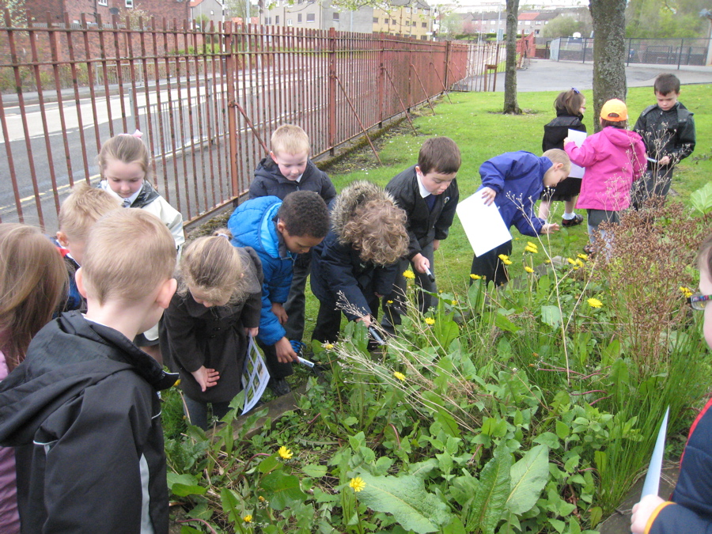
Outdoor Education is delivered through a residential trip to Loch Lomond Outdoor Education Centre at Ardlui. This session the 4 day visit was planned to coincide with 2 of the cluster schools, allowing the children to build relationships prior to their transfer to Dumbarton Academy in August. This was very successful and is already planned for session 2013 – 2014.
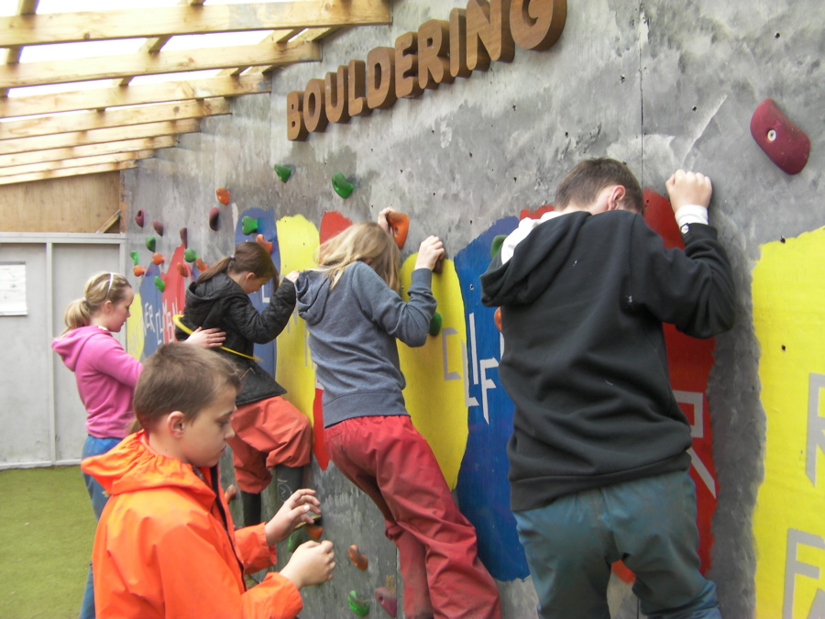

KEY IMPROVEMENTS
School Focus

Quality Indicator 1.1:
4/5

Improvements in Performance Level

Strengths
- Attainment is tracked and monitored regularly – HT / CT meet termly to discuss progress of every pupil
- Results from summative assessments are analysed and used to identify areas for intervention and improvement
- AifL strategies are effectively used in all classrooms
- GL assessment results show improvement from last session
- Staff liaise regularly to advise on prior learning
- A strong focus on Literacy, Numeracy and Health & Wellbeing is evident across all subject areas
- Engaging lessons have resulted in more eager learners
- Achievements are shared with HT who photographs learning and in turn shares with whole school community, parents etc. School website (launched April 2013) is used to showcase performance in and out of class
- Appropriate interventions have resulted in marked improvements in some individuals
- Peer tutors provide support for vulnerable learners
- SNAP group to Glasgow University
- Critical Essay group worked with English Dept. at Dumbarton Academy – high quality writing produced
- High level of support for learning in all categories
- Standards of attainment in Primary 1 pupils are high, particularly in writing where all children are writing independently and enthusiastically by June
- Opportunities for all children are provided – those who are at risk of missing out are specifically targeted for places at after school clubs and supported study classes
- Regular contact with parents encourages support with home learning
- Pupil Councils enable children to contribute to the life of the school – all children are members of 11 different committees
- P6 K’Nex Challenge – 2 x P6 boys reached the area finals
- School shortlisted for Amazing Things Award (Outdoor Learning)
- ‘Read all about it’ notice board of Aitkenbar newspaper articles celebrates achievement
- Primary 6 & 7 residential trip to Ardlui Outdoor Centre

Sporting Achievements this session have been numerous
- Primary 7 girls - WDC Cross Country Champions
- Senior Netball Team – overall winners at Festival
- P7 Rugby Team - WDC Champions
- P4 Tennis Team - WDC Champions
- P4 rugby Team – WDC runners up
- ‘Aitkenbar Achievers’ – awards presented every term for a variety of reasons (effort, manners, kindness, perseverance etc) and letters sent home to parents

Areas for Development
- Improve Numeracy results by setting – three mornings per week (P4/5, P5/6 & P7)
- Improve attendance and timekeeping of some pupils
- Introduce a Teacher Learning to develop consistent practice in formative assessment
- Strengthen family involvement to encourage stronger parental support
- Continue to promote and build resilience and perseverance in all children through a strong focus on Health & Wellbeing Social & Emotional targets
- Continue to develop links already established with local businesses to increase opportunities for learning outwith school

Quality Indicator 2.1:
55

Learners Experiences Level

Strengths
- A strong focus on Outdoor Learning this session has provided exciting, adventurous and rich learning experiences
- Active & Co-operative Learning approaches continue to engage pupils in their learning
- Interdisciplinary topics are planned, developed and evaluated with the children
- High quality feedback helps children to continually improve
- Monday Welcome assemblies bring the school community together – photos and achievements are shared and targets set for the week ahead
- Regular class awards provide incentive and motivation for improvement
- A newly established school website posts photograph albums of trips and events, allowing children to share their experiences with their families
- Children are encouraged to share and celebrate wider achievement by bringing in medals, trophies etc from activities outwith school – photos are displayed in school and on the website
- Rich programme of after school activities for all stages of the school – football, multi sports for infants, rugby, street dance, choir, Kinrick Kids (scripture class) netball, cross country, athletics. lunchtime skipping league
- Opportunities are taken for involvement in spontaneous learning experiences – e.g. Woodland Trust tree planting events, BBC Dancing Quilt project etc.
- Peer and self assessment and evaluation is evident at all stages
- Primary 7 pupils produce personal profiles
- Pupil Voice Committees continue to promote responsible citizenship and develop skills for learning, life and work – children can talk confidently about their role
- A high level of support to vulnerable pupils allows them to feel included and valued
- All children are encouraged to achieve the highest standards possible and to encourage others to do the same
- A SNAP (Scottish Network for Able Pupils) group worked with the PT and attended an event at Glasgow University
- Aitkenbar is registered as a SNAP school

Areas for Development
- Develop better systems for improving attendance in some families
- Introduce profiling and learning targets at each stage
- Focus on Parental / Family Involvement strategies to encourage education to be given higher priority in some households
- Continue to build on the links already established with community partners

Quality Indicator 5.1:
4

The Curriculum Level

Strengths
- Staff are confident in planning programmes of work which deliver the Experiences and Outcomes
- The curriculum is well planned and takes account of the principles and practices of Curriculum for Excellence
- Our children receive breadth, challenge and depth in their learning
- Literacy, Numeracy and Health & Wellbeing are given a high priority in all curricular areas
- All pupils receive 2 hours of PE per week and are aware of healthy life choices
- Interdisciplinary topics are in place throughout the school ensuring a coherent, progressive approach to the curriculum and wide coverage of Experiences & Outcomes
- Creative and innovative teaching strategies promote active and engaging learning experiences, enterprising activities and develop skills for learning, life and work
- Assessment and moderation is built into planning
- Children are involved in topic planning and teachers take note of what they already know and what they would like to learn
- The views of parents are sought and their help with the delivery of the curriculum os welcomed
- Transitions are well managed between stages and at pre-5 and P7/S1
- A strong nursery transition programme is in place
- Opportunities are regularly provided to allow pupils to experience success in wider achievement through various areas of the curriculum e.g. K’nex Challenge
- A variety of learning styles and pupil choice is evident in every class – working in pairs, groups, individually, collaboratively
- Current practice is audited against HGIOS and all staff are involved in the process of designing and adapting the curriculum

Areas for Development
- Ensure the core areas of literacy, numeracy & health & wellbeing are consistently delivered to the highest standard
- Ensure that the topic overview includes enough scope to cater for composite classes
- Continue to maintain strong links with the community and other establishments
- Continue to establish and develop links with more departments at Dumbarton Academy
- Continue to develop BtC 4 – Skills for Learning, Life & Work

4/5

Quality Indicator 5.3:

Meeting Learning Needs Level

Strengths
- Effective Staged Intervention procedures provide early identification of potential additional support needs for less and more able pupils
- Appropriate interventions are introduced to support and challenge as necessary
- Pupils are being challenged by increased pacing
- Primary 3 Collaborative Procedure (screening programme) takes place every September
- Plans are regularly reviewed in consultation with parents and specialist agencies
- The school is well resourced to meet the needs of all learners
- Differentiated work programmes are in place for all abilities across the curriculum
- Learning Assistants are timetabled to deliver one to one support for the most vulnerable children (Toe by toe / Seasons for Growth / Codecracker etc.)
- Extension programmes are provided for the more able pupils – SNAP group / critical essay group / challenging homework projects
- Parents are surveyed to gauge satisfaction levels
- Pupil Support Co-ordinator and Network Support Resource teacher meet weekly to discuss provision of support – adjustments are made as appropriate
- High level of pastoral care from all staff members is evident
- Vulnerable pupils are known and discretely nurtured (uniform, PE kit provision / breakfast)
- All staff have received GIRFEC training
- Strong support from Educational Psychologist, Pupil & Family Support Worker, Social Work, Community Groups and Health professionals
- Good communication and sharing of sensitive information with staff dealing with children who have social & emotional issues
- Resources and training issued to parents to enable targets to be met at home – stile dyslexia, laptop with maths games etc.
- IEPs are in place for a few pupils – targets are regularly set and reviewed
- Support Plans are regularly reviewed
- New targets are shared with key members of staff and parents

Areas for Development
- Continue to focus on pace of learning, personalisation and depth of challenge for all pupils.
- Continue to involve pupils in reviewing their learning targets and evaluating their learning
- Improve family involvement with a view to developing greater home support with learning

Quality Indicator 5.9:
5

Improvement Through Self Evaluation Level

Strengths
- A self evaluation overview ties the many elements together and clarifies the bigger picture
- A systematic assessment calendar details the timings of classroom visits, testing, updating files, profiling, planning/evaluation meetings etc
- Class teachers, PTs and HT track pupil progress carefully. Results inform next steps
- Regular target setting by class teachers is carried out – progress in attainment is tracked and recorded using WDC tracking tool
- Parents, pupils and other stakeholders are asked to complete surveys to allow us to gauge their levels of satisfaction. Results of surveys are discussed and acted upon
- Surveys / audits are carried out with children before and after topics, with parents at parents’ nights and periodically as issues arise
- Pupil and parent surveys provide feedback on school performance
- We consult other service providers – Educational psychologist, social workers etc. and seek their views on the quality of our school
- Regular professional dialogue takes place resulting in adjustments as required
- Detailed evaluations are submitted at the end of each teaching block consisting of ongoing reflective comments throughout the block – points for action are noted and moved forward
- Our school improvement plan is written in consultation with all staff and considers the views of parents, pupils and other stakeholders
- Children in every class are regularly work with their teacher to evaluate their own work and set learning goals for themselves
- Teachers reflect on their work on a daily basis, evaluating lesson plans and identifying next steps
- Classroom visits by HT ensure areas identified in the School Improvement Plan are being delivered
- Staff are given the opportunity to visit each others’ classrooms and share good practice
- Learning conversations take place with children – areas of concern are acted upon
- An ethos of self improvement is evident in everything we do
- Children’s views are regularly sought, their suggestions discussed and action taken where appropriate
- Examples of excellent children’s work are recognised and celebrated on a regular basis

Areas for Development
- Continue to gather the views and opinions of parents and pupils on a wide range of issues
- Involve the pupil committees in evaluating their performance throughout the session
- Focus primarily on evaluation of Learning and Teaching
- Continue to promote dialogue and debate at staff meetings in order to identify areas for improvement

KEY IMPROVEMENTS
Authority Focus
4/5

Quality Indicator 5.5

Expectation and Promoting Achievement Level

Strengths
- High standards are set and all pupils are encouraged to aspire to them
- Staff provide lots of praise and encouragement
- Attendance is carefully monitored and action is taken if there are concerns
- High standards of behaviour are set and steps taken to support children who are struggling to meet them ( behaviour monitoring sheets, Seasons for Growth etc.)
- Children are praised for setting good examples in all areas – standards of work, presentation, behaviour, manners, smart uniform, personal achievement etc.
- Examples of excellent work and effort are shared and displayed around the school
- Pupils are given responsibility for various aspects of school life through pupil councils
- Children and teachers work together to set targets and are aware of how to improve
- Achievements are communicated to the local newspapers and radio station
- A culture of learning, improvement, achievement, praise, encouragement and support exists throughout the school
- Opportunities for pupils to engage with the regeneration of Bellsmyre are taken and children are proud of here they come from
- Opportunities are provided for all learners
- Children are happily engaged in their learning and constantly striving to improve
- Achievements are shared and celebrated through weekly slide shows displaying individual group and class achievements and termly ‘Aitkenbar Achievers’ certificates
- The school website showcases achievements through photograph albums and news items
- Children in our school are well mannered, well behaved and motivated to learn
- Teachers send children to HT and to other classes for special praise
- A ‘can do’ ethos of achievement exists
- Comments / letters from sports coaches provide evidence of a positive, achieving ethos

Areas for Development
- Continue to identify underachievement though existing monitoring strategies and intervene where necessary
- Continue to provide challenging but achievable targets for the most vulnerable
- Continue to involve parents in raising expectation and achievement
- Maintain links already established with industry and community partners – provide career opportunities and aspirations for pupils

School Contact Details

Head Teacher Mrs Christine Hutchison
Address Aitkenbar Primary
Whiteford Avenue
Bellsmyre
Dumbarton
G82 3JL

Tel No 01389 763931
Fax No 01389768807

E-mail schooloffice@aitkenbar.w-dunbarton.sch.uk
Web http://www.scottishschools.info/aitkenbar

We will work together to ensure that everyone in our community is valued and has the opportunity to learn for life and to achieve their potential.
Aim

We aim to enable everyone in West Dunbartonshire to become:

- Successful learners
- Confident individuals
- Responsible citizens
- Effective contributors
now and throughout their future lives.

To achieve our aim, we will:

- Deliver courses and activities which meet the needs of all learners
- Provide services and manage resources to support learning
- Value differences, promote equal opportunities and foster inclusion
- Promote partnership, collegiality and community participation
- Celebrate success
- Monitor, evaluate and review the quality of our services

West Dunbartonshire Council:
An Education Authority of Ambition

