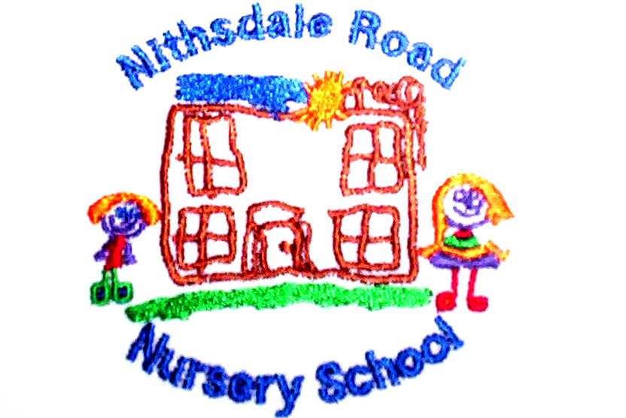


NEWSLETTER

October 2020



Nithsdale Road Nursery School, 264 Nithsdale Road,
Glasgow, G41 5LB TEL: 0141 427 1896


Dear Parent

The children have settled well this year and they are becoming more confident with the nursery layout and our routines both indoors and out.

Your opinion is very important to me and I believe that we cannot deliver the best service without your help. If there are any aspects of our service that you feel we could improve on or indeed there are aspects of our service that you particularly like, please let us know.

My email is Headteacher@nithsdaleroad-nursery.glasgow.sch.uk

I look forward to the next year working with you and getting to know you.

Many thanks


COVID -19
The whole nursery community should be vigilant for the symptoms of COVID-19:
- New continuous cough.
- Fever/High temperature
- Loss of, or change in sense
The children are very good with their hand washing routines. All children wash their hands when they arrive at nursery, before snack, after going to toilet and at the end of the session. As the year goes on we will be indoors more and we continuously review our processes in order to keep everyone safe.

OUTDOORS


As we spend much of our time outdoors it is a good idea for you to ensure that your child has suitable clothing for outdoor play (Wellies, Hat, gloves, waterproof jacket/suit) we do have a good supply of waterproof clothing which your child can use. It is also a good idea to put your child’s name on their belongings

Forest Kindergarten

It is hoped that all of our pre-school children will have the opportunity over the coming year to be part of our Forest Kindergarten project. Nursery staff have undertaken training in this exciting way of teaching and will take a group each week to Bellahouston Park, where they will enjoy a range of outdoor activities, including storytelling, exploring, den building and most importantly getting muddy and having fun! The first sessions are due to begin after the October break.

Each project is child led so that we ensure they have the freedom to explore, be creative, challenge themselves and develop a sense of appreciation and wonder for the natural world around them. We bring the children to the same site each week, in all weathers, so that they can see how nature grows and develops.

Research has shown that by learning outdoors, the children are more focused, less frustrated, restless and healthier. Parents are welcome to join us at the
Forest.

Promoting Positive Behaviour
All staff has high expectations on how children behave at nursery and this is supported by the use of Golden Rules and our PATHS Program.

I hope you all received your copy of our Golden Rules. Please talk to your child about the rules and how they apply both at home and in nursery:


- We are gentle.
- We are kind and helpful.
- We listen.
- We are honest.
- We work hard.
- We look after everything.

Our Golden Rules are displayed around the nursery. PATHS will be starting very soon and is overseen by Mrs. Mary Cumming.

PATHS
Our PATHS Program will be starting up again soon. We will begin introducing PATHS with the children from Monday 26th October. The PATHS Curriculum is designed to build children’s self-esteem and encourage children to support and respect others.

Child Protection: Whilst it is the responsibility of all for the welfare and safety of the children, as Head of Nursery, I am the named child protection coordinator and I am responsible for any child protection issues that may arise.

Toy Fund
Remember you can pay Eileen your toy fund (£3.00 per week) weekly, monthly or termly. The toy fund pays for children’s snacks, outings, parties, Christmas and birthday gifts and nursery resources. Thank you for your continued contributions and support it is really appreciated particularly at this time.


October Holiday
We are closed:
Friday 9th October In Service Day
Monday 12th till Friday 16th (inclusive) October Holiday

Farewell Miss Wilson
Miss Lorna Wilson who has been a valued member of staff here at Nithsdale since 10th November 1986 will retire on Friday 9th October 2020. Her last day with the children will be next Thursday. Many of our families including several generations know Miss Wilson and I am sure have so many great memories associated with Nithsdale Road. I am sure like us we wish Lorna a long and healthy retirement and everyone here will miss her so much. Goodbye and Good luck Lorna.



You can join us on

Twitter @Nithsdaleroad NS

Many thanks.
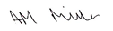

Annemarie Miller
HEAD OF NURSERY

