[](http://www.google.co.uk/url?sa=i&rct=j&q=&esrc=s&source=images&cd=&cad=rja&uact=8&ved=&url=http://westonpoint.halton.sch.uk/Pages/Homework.aspx&psig=AOvVaw0Hsr5EjRSDKQtemgLtiHLg&ust=1518173319460808)

* ***Parent/Carers’ Role:*** 
  + *Please find your child a suitable space to carry out their homework depending on the type of task set;*
  + *Check your child’s homework is their best work but please do not do the homework for them or ‘correct’ their errors. It is important for the teacher to see if your child needs further teaching to aid their understanding.*
  + *Do encourage your child to ‘self-assess’ (check over) their own work for errors and improve it where possible.*
  + *Do encourage good presentation eg sharp pencil etc.*
  + *Do ensure oral and practical work is completed, not simply the written tasks. Join in talk tasks as appropriate with your child.*
  + *Please sign their sheet/homework diary to show that you are aware of what homework has been completed.*
* ***Pupil Role:***
  + *To listen to the explanation of homework tasks in class and/or copy homework carefully into homework diaries/jotters.*
  + *To find a suitable time and place to carry out homework (P4-7). P1-3 will need parental help with this.*
  + *To try their hardest with each task including presentation.*
  + *To complete their homework tasks and hand them in on time.*
* ***Teachers’ Role:***
  + *To set tasks as appropriate following the agreed guidance.*
  + *To ensure pupils’ understanding of tasks before they are given home.*
  + *To ensure tasks are planned to meet pupil needs.*
  + *To give pupils appropriate feedback.*
* ***SMT Role:***
  + *To monitor homework throughout the school liaising with pupils, staff and parents as appropriate.*
  + *To initiate the update of the homework guidance as appropriate.*

***General Guidance:***

* *All children (even on weekdays) should have time left during their evenings to go to clubs, spend time with their family (playing games/talking etc), attending a special event at home or indeed getting to bed at a reasonable time.*
* *The following is the suggested time allocations for each stage (this includes both written and oral homework):*
  + *P1-3 = 15-20 minutes per night maximum*
  + *P4-7 = 20-30 minutes per night maximum*

*If your child is taking longer than this, there is no need to continue with the homework: just sign the sheet/diary and write in a brief note outlining the difficulty.*

***Weekly and Termly Guidance:***

* *In general, homework should be given on a* ***Monday*** *to be returned on a* ***Friday*** *(although children should be allowed to hand in their completed homework early and the teacher may give the occasional**task to be completed for the following day or a particular day eg a writing plan for their writing day on a Thursday).*
* *Topic/project homework may be given over a much longer period. Whilst models etc can be a family effort, your child’s work should be evident.*
* ***One curriculum area*** *should be given per night in P1-7. In P1-3 this should also be limited to one task although in P4-7 this can be more than one task (eg Literacy: a spelling task and a reading task or in Numeracy: a written number task and a practical shape task).*
* *At least one night each week should focus on Literacy and one night on Numeracy (although Literacy may be spread across two nights eg Spelling one night and Reading task another night or talk preparation for their writing etc). Literacy and Numeracy tasks should be a mixture of written and oral throughout the term. A big focus should always be on* ***Reading****. Reading for Enjoyment (class or home books) can also be given in addition to the set tasks for P1-7.*
* *The remaining 1 or 2 nights should cover a* ***varied range of curricular areas*** *throughout each term. Health and Wellbeing (including physical activity and sport) should also be given regularly. Other areas include RE, Art and Design, French, Music, Dance, topic etc.*
* *When children are preparing for Sacraments such as Reconciliation, the Eucharist or Confirmation, there will be a strong focus on RE across that term. Special arrangements will be given for the return of this homework.*
* *On any of the 4 nights Monday-Thursday, at least one of the night’s homework should be* ***completely oral or practical*** *(eg Oral: Read chapter 2 of a chosen novel at home and discuss the main character(s) with your parent) or (eg Practical: Practise throwing and catching a medium sized ball with your parent or use a stop watch to jog on the spot for 30 seconds etc).*

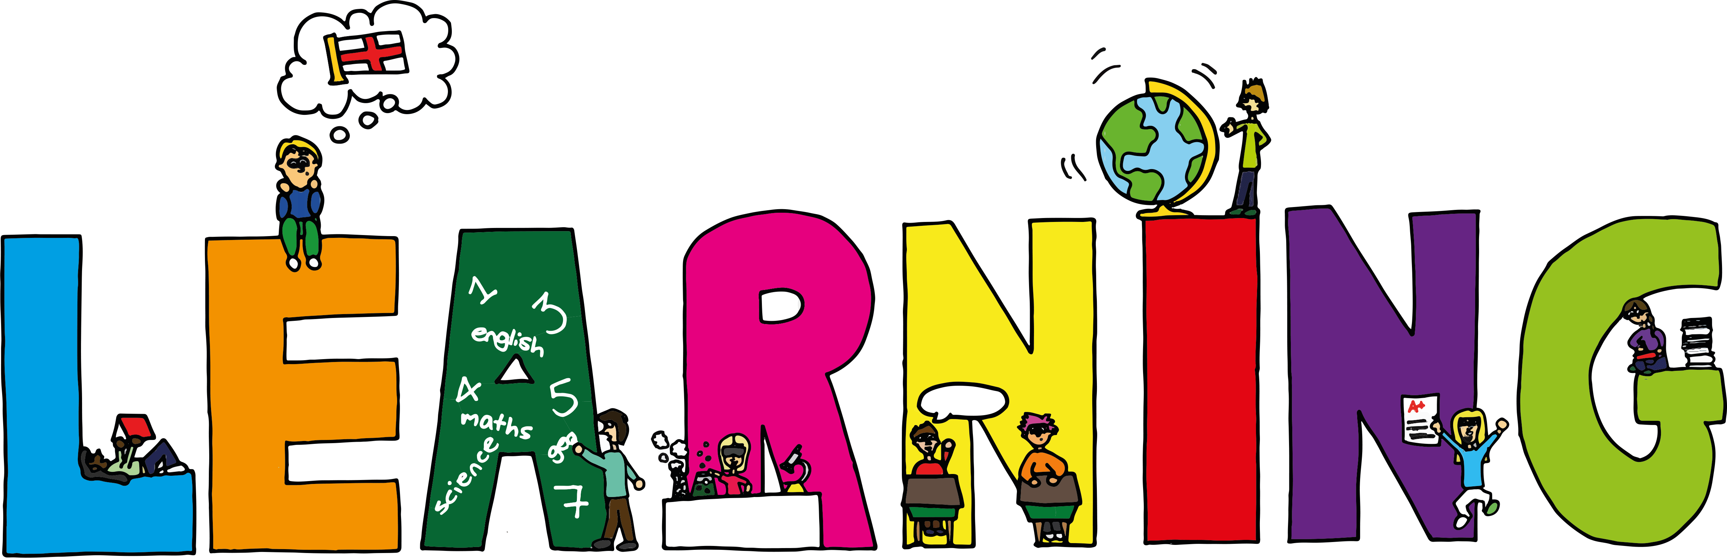





**Homework in**

**Our Lady of Lourdes**

Homework in Our Lady of Lourdes is structured in consultation with the pupils, staff and parents. It is the combined ‘voices’ of all of these stakeholders that has written this document. It has been proven that when parents/carers and schools work together, children do better.

**So why is homework important?**

Homework should help the **children** to do the following:

* *Practise and build on what they have learned at school;*
* *Link school work to real life;*
* *Take more responsibility for their own learning;*
* *Learn how to organise and manage their time;*
* *Learn and work independently.*

Homework helps **teachers** to do the following:

* *Check (in a different context) the child's understanding of classwork;*
* *Due to the reinforcement or enquiry given at home, work at a faster pace of learning with the child;*
* *Liaise with parents about their child’s learning.*

Homework should help **parents** to do the following:

* *Engage in their child’s learning;*
* *Gain a window into the classroom and give an ongoing picture of how their child is doing with their learning;*
* *Support their child’s learning at home improving their chances*

*of becoming a successful learner.*

* *In general, tasks should be as* ***active and fun*** *as possible whilst still reinforcing key learning (eg ‘counting on’ in Maths can be reinforced by playing ‘Snakes and Ladders’).*
* ***Outdoor learning*** *opportunities should be given throughout each term with a particular focus on the summer term.*
* *As much as possible throughout the week, tasks should link to* ***real life*** *(eg Find a range of 3D shapes in your kitchen at home and make a note of how many sides and corners each of the items had/find 5 adjectives in a reading book from home/draw a tree that is near your house then describe what it tells you about the current season).*
* *Tasks should also be* ***relevant*** *when appropriate eg related to the Olympic Games, St. Andrew, seasonal etc.*
* *Parents will be given a list of* ***key learning*** *at the beginning of each year in* ***Literacy and Numeracy*** *as well as suggested online learning etc which offer parents the ability to give their child additional homework tasks if they wish to supplement their child’s homework. Board games are also a good source of reinforcing key learning eg Scrabble, Monopoly, Connect Four, Boggle, Dominoes, What’s Up etc.*
* *On occasion, a homework task may simply be to explain to their parent what they have been learning in class that day related to one curriculum area. (Children learn something really well when they can talk about it/explain it to someone else).*
* *P1-4 will continue to be given homework diary sheets/P5-7 will continue to use homework diaries.*
* *Homework passes will be used as an incentive for good behaviour (P4-7).*
* ***No homework*** *should be given on nights when a* ***known event*** *is taking place (eg Parents’ Evenings, Hallowe’en, Bonfire Night, PTA Events etc). In addition, no child will be required to do homework on the evening of their own birthday. Parents/child can simply write birthday beside the day in their sheet/diary to remind the teacher of this when it comes to corrections.*
* ***No homework*** *should be given throughout the months of* ***December*** *or* ***June*** *(other than to learn parts for their show/words for the songs/carols in concerts etc or suggested activities such as to carry out Acts of Kindness at home (eg help to put up the Christmas tree etc, go on a nature walk, visit the park).*

We are all in agreement, that **quality matters much more than quantity**: the kind of homework your child is given is much more important than the amount. If you wish your child to do more homework than is given, please refer to the key learning at the beginning of the year and the further suggested activities.